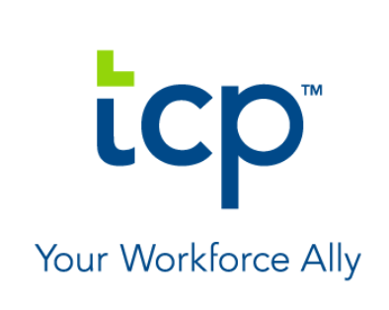
TCP Demonstrates Continued Growth Strategy with the Acquisition of Humanity
Workforce management solution optimizes productivity with enhanced employee scheduling capabilities

AUSTIN, Tex.—December 2, 2020—TCP (TimeClock Plus), a leading provider of workforce management and time and labor solutions, today announced the acquisition of Humanity, an industry-leading cloud-based employee scheduling platform that enables its customers to easily and accurately create dynamic schedules for staff. The feature-rich, proven scheduling solution will be integrated into TCP’s cloud-based workforce management software suite.
“Over the last year, we’ve made big strides to become a workforce management leader—from new funding and leadership, to delivering a new brand experience and a new way of thinking about our contributions to the workforce management field,” stated Eric Thurston, CEO at TCP. “Our first acquisition is an exciting next chapter in our story as we continue to focus on the needs of our customers, and we are thrilled to welcome Humanity into the TCP family.”
Humanity is a top-tier employee scheduling solution used by more than 175,000 business locations to manage schedules, employee availabilities, shift trades and day-off requests. The software simplifies day-to-day employee scheduling to easily and accurately create error-free, dynamic schedules for staff by location, department, position and/or skills—with real-time availability and conflict checking. Humanity’s scheduling features will enhance the TCP workforce management solution.
Highlights include:

Forecasting - Predict staffing needs based on key business metrics and tie-in with the scheduling process. Integrate point-of-sale and other external business data to forecast scheduling needs from week to week based on sales, foot traffic and other important KPIs.

Compliance - The custom rules engine ensures schedules are compliant with federal, state and local regulations with instant conflict warnings. Guarantee laws are followed for hours worked, break frequency, time between shifts and more.
Mobile Shift Management - Empower employees to manage schedules from their mobile device. Employees can request time off, release shifts, pick up open shifts and adjust their availability with minimal supervisor involvement. Create multiple locations and departments as needed and manage them all from one account or divide into group accounts with custom access and permissions.

Auto and Flex Scheduling - Automatically generate conflict-free schedules, copy shifts, import schedules, etc. Set rules to avoid overtime and undertime and optimize schedules by assigning shifts based on custom variables, such as seniority and preferences, with rules for maximum days in a row and shift limits.
Real Time Schedule Updates - Updates display in real time where you are overstaffed or understaffed. This allows managers to respond to changes in business circumstances such as posting open shifts and released shifts for pickup, or quickly finding a replacement for an absence.

“Humanity's mission is to give organizations better control over their work schedules while ensuring maximum productivity, and this move will help us achieve that mission on an even larger scale than before,” said Chris Amani, CEO at Humanity. “We are delighted to align ourselves with TCP and incorporate our scheduling tools into their comprehensive workforce management suite of solutions.”

Deutche Bank and Goodwin Proctor acted as financial advisor and legal advisor, respectively, to Humanity.

About Humanity
Humanity offers a cloud-based employee scheduling platform that accelerates schedule creation by up to 80 percent while providing organizations of all sizes with unprecedented insight into their operations and empowering them with actionable data to optimize staffing based on historical sales and sales forecasts, employee skill set, and staff availability. Since 2010, more than 7,000 customers representing 1.3M users have scheduled over half-a-billion shifts on Humanity.

About TCP
For more than 30 years, TCP (TimeClock Plus) has helped organizations engage their people by providing flexible, mobile timekeeping and workforce management solutions. Trusted by tens of thousands of customers and millions of users, TCP delivers best-in-class technology and personalized support to organizations of all sizes in the public and private sectors to meet their complex timekeeping, employee scheduling, leave management, and other workforce needs.

For more, visit www.tcpsoftware.com or follow us on LinkedIn or Facebook.

